# Object Annotator – Brief instructions

Object annotator is the simple application designed for object labeling. The annotated objects are needed for machine-learning based techniques such as Viola-Jones approach. Brief instructions are written below:

## Opening files

**Recursive directory search:**

if checked all subdirectories will be read;

default option is to read only the top directory

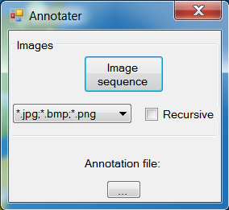

**Open or create annotation file:**

The option is available after the image sequence is selected.

**WARNING:** the location of an image sequence folder(s) must be a subfolder relative to an annotation file

**Image type:**

select image type; deafult option is all supported image types

**Open image sequence:**

folder containing images

## Interface

After the image sequence and the annotation file are opened, the main interface is shown.

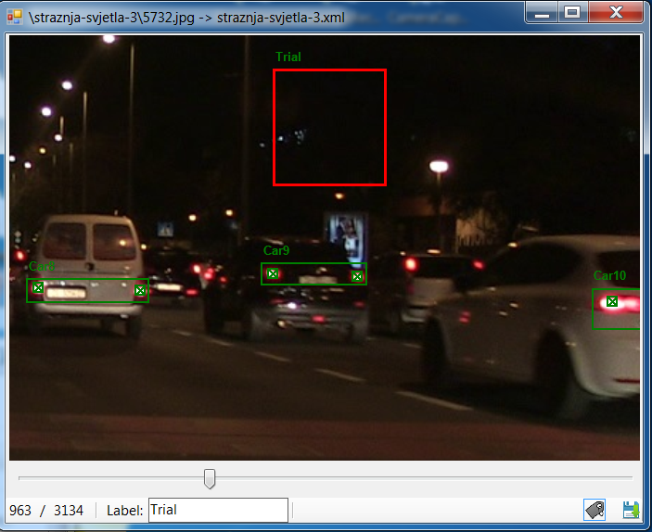

**Selected annotation**

**Slider**

**Current image**

**Current image name**

**Selected annotation label**

**Save**

**Toggle labels**

### Annotating

#### Creating

The annotator is capable to annotate bounding boxes as well as locations represented by “X”. In order to make a bounding box press and hold the left mouse button, move the mouse, and release the button after the box is made. Mouse left key press is needed to mark a location. Switching between annotation types is easy: right click outside annotations to show the menu (as shown below). Select the appropriate annotation type.

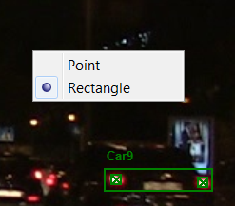

#### Erasing

Right click the annotation. The annotation will become red. Press *Delete* to remove it.

#### Labeling

Right click the annotation. The annotation will become red. Insert the text in the label text box.

**Tip:** annotate objects of the same label first because after the first annotation is made and the label is created every new annotation will contain the same label by default. This procedure can speed up annotation process.

#### Saving

Press the Save button  or *Ctrl + S* to save the progress. The application will warn you upon closing if annotations are not saved.

### Other

#### Zooming

In order to mark locations more accurately the application has a zoom option. To activate the zoom press and hold the *Shift* button. By moving your mouse, the image is translated. Use the mouse wheel, or smart pad if laptop, in order to enlarge / shrink the image. The result is shown below.

